**1. What is software? What is software engineering?**

**Ans. What is Software:**

Software is a collection of data, programs, procedures, and instructions that tell a computer how to work. It is the non-physical part of a computer system, as opposed to hardware, which refers to the physical components.

here are generally two main types of software:

* System Software: Helps run the hardware and system.

For Example: operating systems like:

Windows

Linux

Application Software: Helps users perform specific tasks.

For Example:

Microsoft word

Web browsers

Games

**What is Software Engineering:**

Software Engineering is the systematic application of engineering principles to the development, operation, and maintenance of software.

Software Engineering involves:

- Requirements gathering

-Design

-Implementation (coding)

-Deployment

- Maintenance

The goal of software is to develop High Quality software which would be:

-Reliable

-Requirements gathering

-Design

-Implementation (coding)

-Testing

-Deployment

-Maintenance

**Software engineering** is the disciplined and structured approach to designing, creating, testing, and maintaining software.

**2. Explain types of software**

**Ans.**  There are two types of software:

1. system software

2. Application software

**System software:**

System software is the type of software designed to manage and control the hardware components of a computer system. It acts as a bridge between the user, the hardware, and application software

The main functions of **system software** are as follow:

-Controls hardware operations

-Provides a platform for running application software

- Manages system resources (CPU, memory, devices).

**Application software:**

Application software is designed to help users perform specific tasks or applications on a computer or mobile device.

The main functions of **Application software** are as follow:

-Solves real-world problems for users

-Provides tools for productivity, communication, entertainment, etc.

**This above information explains about software and types of system software.**

**3. What is SDLC? Explain each phase of SDLC**

**Ans. SDLC** stands for **Software Development Life Cycle.** It is a step-by-step process used to design, develop, test, and maintain software. The goal of SDLC is to produce high-quality software that meets customer needs, within time and budget**.**

The phases of **SDLC:**

**1.** Requirement gathering and Analysis

**2**.System Design.

**3.** Coding.

**4.** Testing.

**5.** Maintenance.

Explaination of all phases:

**Requirement Gathering & Analysis:**

* Understand what the client or user needs.
* Gather and document requirements.
* Analyz if the project is possible (feasibility study).

**System Design:**

* Plan how the software will work.
* Design architecture, data flow, user interfaces, etc.

**3. Implementation / Coding**

* Developers write code based on the design.
* Programming languages and tools are used.

**4.Testing**

* Check if the software works correctly.
* Find and fix bugs or errors.
* Types: Unit testing, Integration testing, System testing.

**5. Maintenance**

* Ongoing support after deployment.
* Fix issues, update features, improve performance.

**This were the all phases of SLDC.**

**4. What is DFD? Create a DFD diagram on Flipkart.**

**Ans.** DFD stands for Data Flow Diagram.  
It is a graphical representation that shows how data moves through a system. It illustrates:

* Processes (what the system does)
* Data stores (where data is stored)
* External entities (users or systems interacting with it)
* Data flows (movement of data)

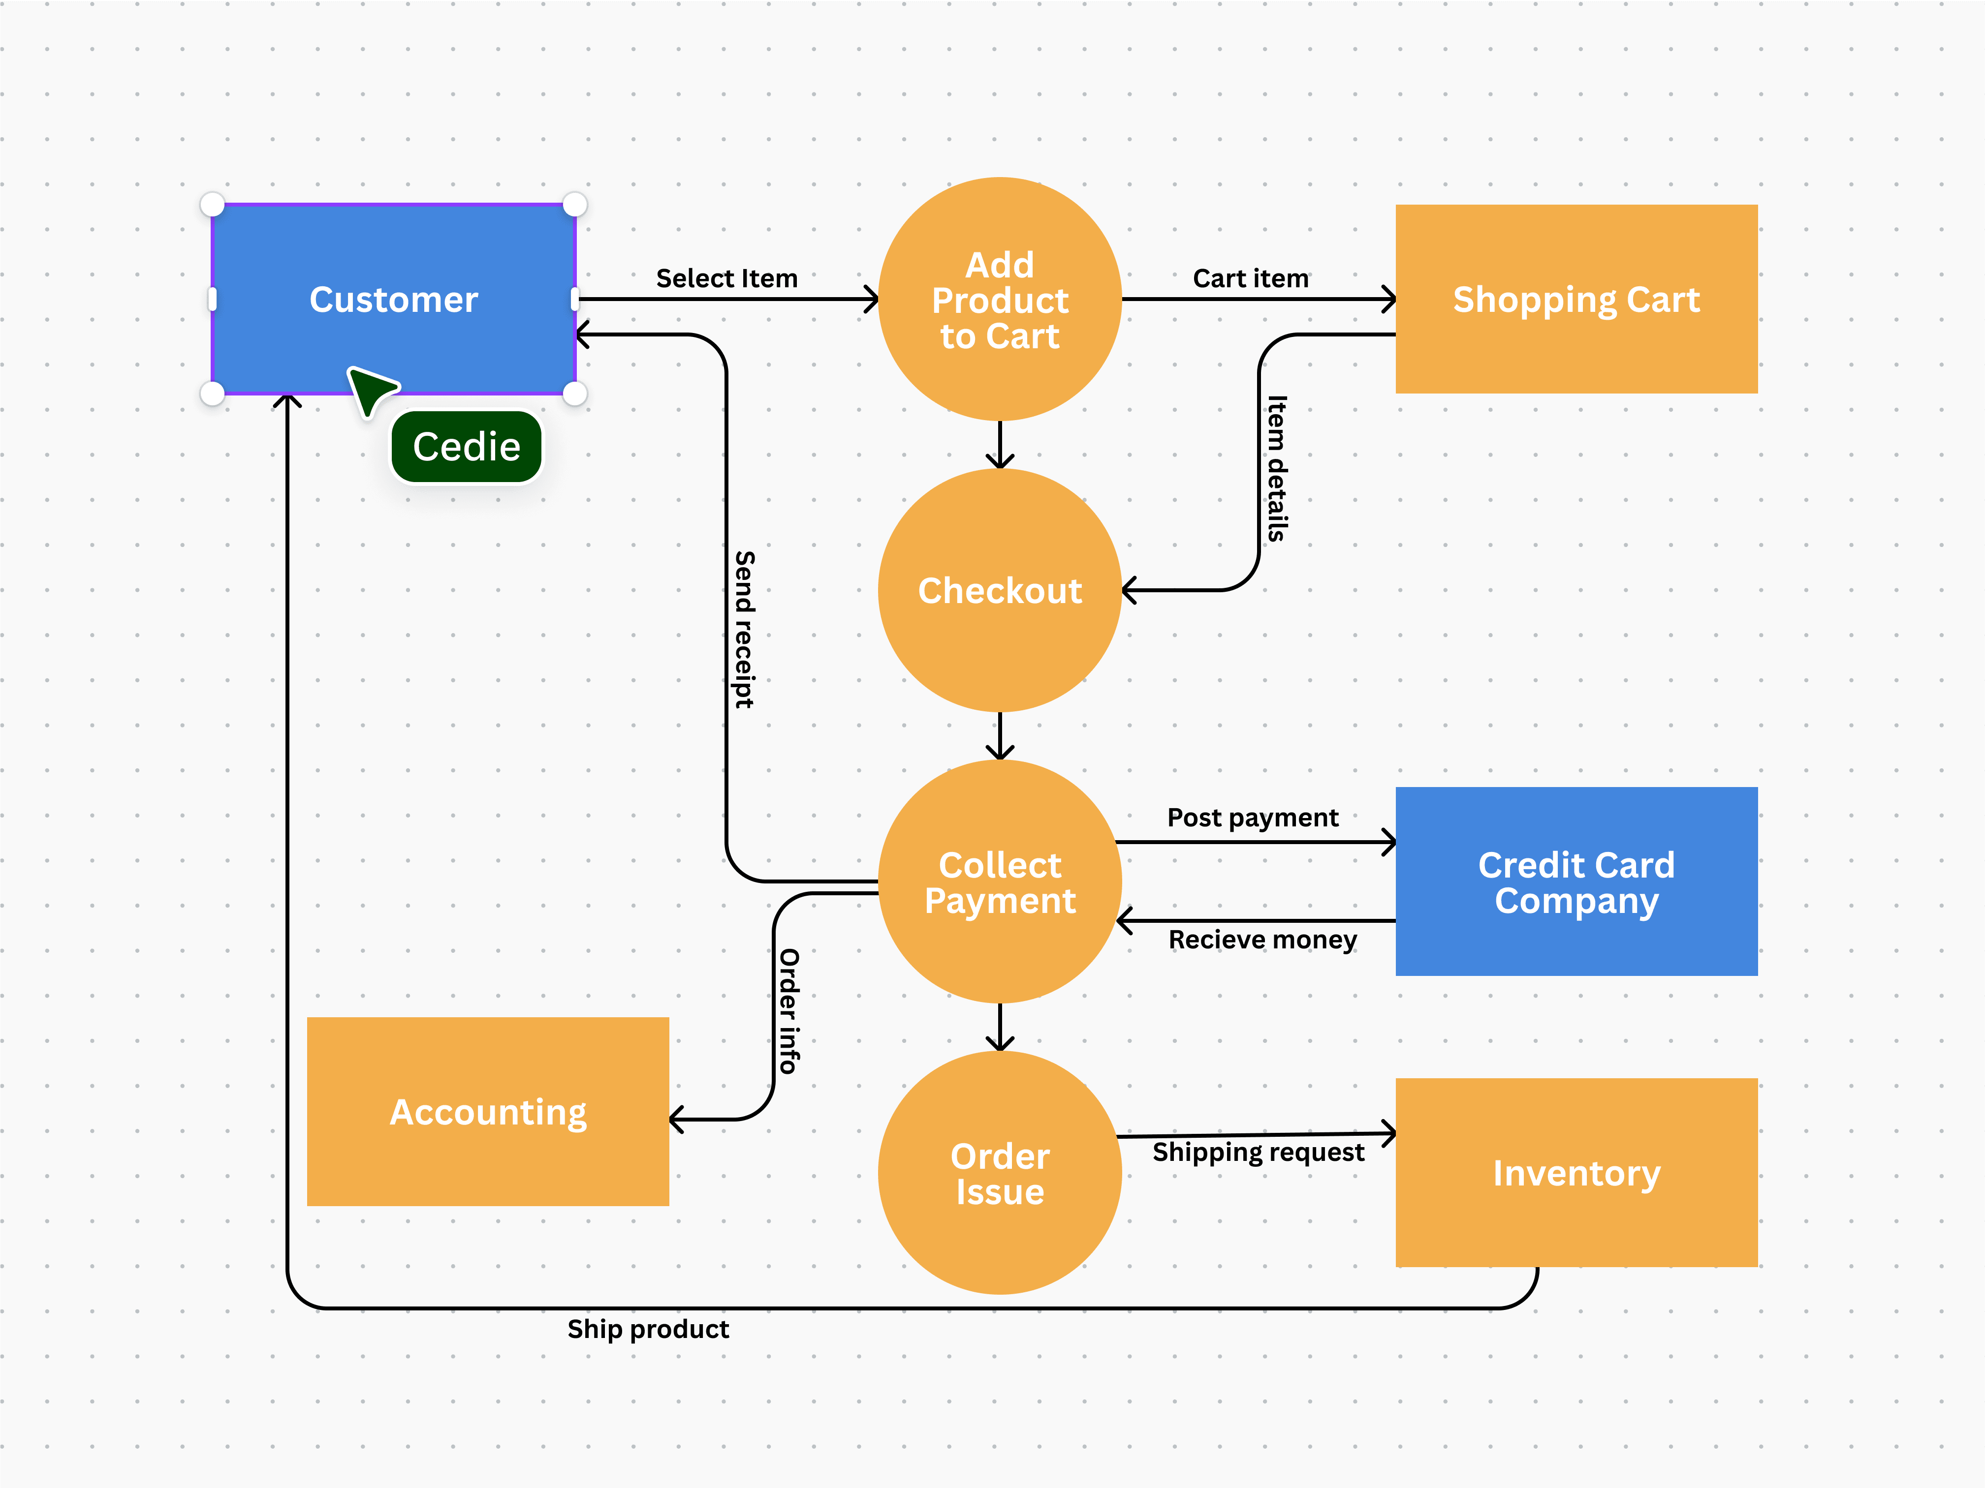

Dfd for flipkart.

**5. What is Flow chart? Create a flowchart to make addition of two numbers**

**Ans**. A flowchart is a diagram that represents an algorithm, process, or workflow using different symbols. It shows the step-by-step sequence of operations to solve a problem.

**Common flowchart symbols:**

* **Oval** → Start/End
* **Parallelogram** → Input/Output
* **Rectangle** → Process/Calculation
* **Diamond** → Decision (Yes/No)
* **Arrows** → Show the flow

**🔹 Flowchart for Addition of Two Numbers**

**Steps:**

1. **Start**
2. **Input** two numbers (say A and B)
3. **Process**: Add the two numbers (SUM = A + B)
4. **Output** the result (SUM)
5. **End**

The flow chart for addition of two numbers.

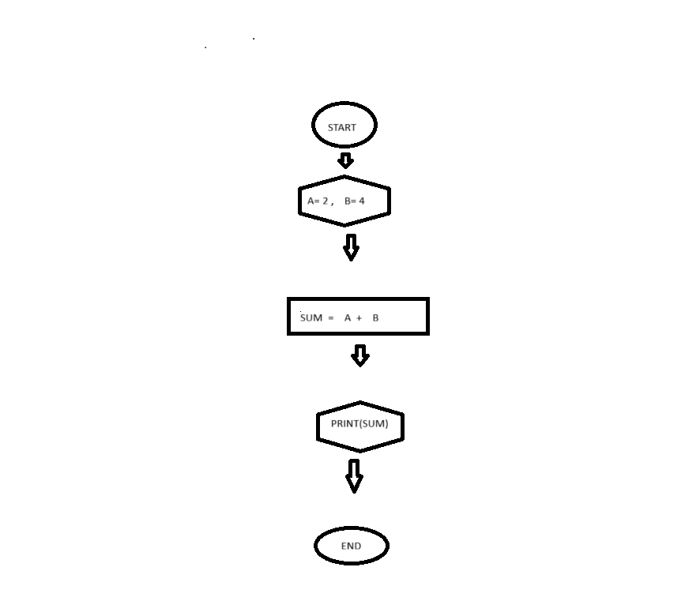

Flowchart for addition of two numbers.

6.**What is Use case Diagram? Create a use-case on bill payment on paytm.**

**Ans.** Use Case Diagram is a type of UML (Unified Modeling Language) diagram that visually represents the interactions between actors (users or external systems) and the system to achieve a specific goal.  
It shows what the system does (functional requirements) without explaining how it is implemented.

**ey Components of a Use Case Diagram**

* **Actors** → Users or external systems interacting with the system.
* **Use Cases** → Functionalities or services the system provides.
* **System Boundary** → Defines what is inside (system’s responsibilities) and outside (actors).
* **Relationships** → Associations between actors and use cases (include, extend, etc.).

**se Case: Bill Payment on Paytm**

**Actors**

* **User/Customer** (who pays the bill)
* **Bank/UPI Service** (external system for payment)
* **Paytm System**

**Use Cases**

* Login / Register
* Select Bill Payment option
* Choose Bill Type (Electricity, Water, DTH, Mobile, etc.)
* Enter Bill Details (Consumer Number, Phone Number, etc.)
* Verify Bill Amount
* Select Payment Method (UPI, Wallet, Debit/Credit Card, Net Banking)
* Make Payment
* Generate Transaction Receipt

Above content shows information about use case bill.

